Grant Programs Directorate


OMB Control#: 1660-0115
Expiration Date: 01/31/2017
FEMA Form: 024-0-1

DEPARTMENT OF HOMELAND SECURITY
FEDERAL EMERGENCY MANAGEMENT AGENCY (FEMA)
ENVIRONMENTAL AND HISTORIC PRESERVATION SCREENING FORM

Directions for completing this form: This form is designed to initiate and facilitate the environmental and historic preservation (EHP) compliance review for your FEMA preparedness grant-funded project(s). FEMA conducts its EHP compliance reviews in accordance with National Environmental Policy Act (NEPA) and other EHP-related laws and executive orders. In order to initiate EHP review of your project, you must complete all relevant sections of this form and submit it to the Grant Programs Directorate (GPD) along with all other pertinent project information. Failure to provide requisite information could result in delays in the release of grant funds. Be advised that completion of this form does not complete the EHP review process. You will be notified by FEMA when your review is complete and/or if FEMA needs additional information.

There is no need to complete and submit this form if the grant scope is limited to planning, management and administration, classroom-based training, tabletop exercises and functional exercises, or purchase of mobile and portable equipment where no installation is needed. The following website has additional guidance and instructions on the EHP review process and the information required for the EHP review: at http://www.fema.gov/media-library/assets/documents/85376.

This form should be completed electronically. Submit completed form through your grant administrator who will forward it to GPDEHPInfo@dhs.gov. Please use the subject line: EHP Submission: Project Title, location, Grant Award Number (Example, EHP Submission: Courthouse Camera Installation, Any Town, State, 12345; 2011-SS-0xxxx).

PROJECT INFORMATION
DHS Grant Award Number:
Grant Program:
Grantee:
Grantee POC:
Mailing address:
E-mail:
Sub-grantee:
Subgrantee POC:
Mailing address:
E-mail:
Estimated cost of project:
Project title:
Project location (physical address or latitude-longitude):
Project Description. Provide a complete project description. The project description should contain a summary of what specific action is proposed, where it is proposed, how it will be implemented. Include a brief description of the objectives the project is designed to accomplish (the purpose), and the reason the project is needed. Use additional pages if necessary. If multiple sites are involved, provide the summary for each site:

PROJECT TYPE
Based on the proposed project activities, determine which project type applies below and complete the corresponding sections that follow. For multi-component projects or those that may fit into multiple project types, complete the sections that best apply and fully describe all major components in the project description. If the project involves multiple sites, information for each site (such as age of structure, location, ground disturbance, etc.) must be provided. Attach additional pages to this submission, if needed.
- Purchase of equipment. Projects in this category involve the purchase of equipment that will require installation on or in a building or structure. Complete other portions of Section B as needed. Complete Section C.1.
- Training and exercises. Projects in this category involve training exercises with any field-based components, such as drills or full-scale exercises. Complete Section C.2.
- Renovations/upgrades/modifications or physical security enhancements to existing structures. Projects in this category involve renovations, upgrades, retrofits, and installation of equipment or systems in or on a building or structure. Examples include, but are not limited to: interior building renovations; electrical system upgrades; sprinkler systems; vehicle exhaust systems; closed circuit television (CCTV) cameras; security fencing; access control for an area, building, or room; bollards; motion detection systems; alarm systems; security door installation or upgrades; lighting; and audio-visual equipment (projectors, smart boards, whiteboards, monitors, displays, and projector screens). Complete Section C.3.
- Generator installation. Projects in this category involve installation of new or replacement generators, to include the concrete pads, underground fuel and electric lines, and if necessary, a fuel storage tank. Complete Section C.4.
- New construction/addition. Projects in this category involve new construction, addition to, or expansion of a facility. These projects involve construction of a new building, or expansion of the footprint or profile of a current structure. Complete Section C.5.
- Communication towers, antennas, and related equipment. Projects in this category involve construction of new or replacement communications towers, or installation of communications-related equipment on a tower or building or in a communications shelter or building. Complete Section C.6.
- Other. Projects that do not fit in any of the categories listed above. Complete Section C.7.

PROJECT TYPE DETAILS
Check the box that applies to the proposed project and complete the corresponding details.

Purchase of equipment. If the entire project is limited to purchase of mobile/portable equipment and there is no installation needed, this form does not need to be completed and submitted.
    - Specify the equipment, and the quantity of each:
    - Provide the Authorized Equipment List (AEL) number(s) (if known):
    - Complete Section D.

Training and exercises. If the training is classroom and discussion-based only, and is not field-based, this form does not need to be completed and submitted.
    - Describe the scope of the proposed training or exercise (purpose,
materials, and type of a activities required):
    - Provide the location of the training (physical address or latitude-
longitude):
    - Would the training or exercise take place at an existing facility which has established procedures for that particular proposed training or exercise, and that conforms with existing land use designations? For further information refer to policy guidance at
http://www.fema.gov/media-library/assets/documents/85376: Yes No
- If Yes, provide the name of the facility and the facility point of
contact (name, telephone number, and email address):
- If No, provide a narrative description of the area where the training
or exercise would occur (e.g., exercise area within four points
defined by latitude/longitude coordinates):
    - Does the field-based training/exercise differ from previously permitted training or exercises in any way, including, but not limited to frequency, amount of facilities/land used, materials or equipment used, number of participants, or type of activities? Yes No
- If Yes, explain any differences between the proposed activity and
those that were approved in the past, and the reason(s) for the change
in scope:
- If No, provide reference to previous exercise (e.g., FEMA grant
name, number, and date):
    - Would any equipment or structures need to be installed to facilitate training? Yes No
- If Yes, complete Section D

Renovations/upgrades/modifications, or physical security enhancements to existing structures.
    - Complete Section D.

Generator installation.
    - Provide capacity of the generator (kW):
    - Identify the fuel to be used for the generator (diesel/propane/natural gas):
    - Identify where the fuel for the generator would be stored (e.g. stand-alone
tank, above or below ground, or incorporated in generator):
    - Complete Section D.

New construction/addition.
    - Provide detailed project description (site acreage, new facility square
footage/number of stories, utilities, parking, storm-water features, etc.):
    - Provide technical drawings or site plans of the proposed project: Attached
    - Complete Section D.

Communication towers, antennas, and related equipment.
    - Provide the current net height (in feet above ground level) of the existing
tower or building (with current attached equipment):
    - Provide the height (in feet above ground level) of the existing tower or
building after adding/replacing equipment:
Complete items 6.c through 6.q below ONLY if this project involves construction of a new or replacement communications tower. Otherwise continue to Section D.
Information regarding National Historic Preservation Act Section 106 Review Requirements for Communications Facilities and information on EHP requirements for communications towers is available at: http://www.fema.gov/media-library/assets/documents/85376.
    - Provide the ground-level elevation (feet above mean sea level) of the site
of the proposed communications tower:
    - Provide the total height (in feet above ground level) of the proposed
communications tower or structure, including any antennas to be mounted:
- If greater than 199 feet above ground level, state why this is needed
to meet the requirements of the project:
    - Would the tower be free-standing or require guy wires? Free standing Guy wires
- If guy wires are required, state number of bands and the number of
wires per band:
- Explain why a guyed tower is needed to meet the requirements of
this project:
    - What kind of lighting would be installed, if any (e.g., white strobe, red
strobe, or steady burning)?
    - Provide a general description of terrain (e.g., mountainous, rolling hills,
flat to undulating):
    - Describe the frequency and seasonality of fog/low cloud cover:
    - Provide a list of habitat types and land use at and adjacent to the tower
site (within ½ mile), by acreage and percentage of total (e.g., woodland
conifer forest, grassland, agriculture) water body, marsh:
    - Is there evidence of bird roosts or rookeries present within ½ mile of the proposed site? Yes No
- Describe how presence/absence of bird roosts or rookeries was
determined:
    - Identify the distance to nearest wetland area (e.g., forested swamp,
marsh, riparian, marine) and coastline if applicable:
    - Distance to nearest existing telecommunication tower:
    - Have measures been incorporated for minimizing impacts to migratory birds? Yes No
- If Yes, describe:
    - Has a Federal Communications Commission (FCC) registration been obtained for this tower? Yes No
- If Yes, provide Registration #:
- If No, why?
    - Has the FCC E106 process been completed? Yes No
    - Has the FCC Tower Construction Notification System (TCNS) process been completed? Yes No
- If Yes, attach the environmental documentation submitted as part of
the registration process including use of the Tower Construction
Notification System (TCNS), if applicable. FRN#:
    - Would any related equipment or structures need to be installed (e.g., backup generator and fuel source, communications shelter, fencing, or security measures)? Yes No
- If Yes, explain where and how each installation would be done. Provide
details about generator capacity (kW), fuel source, fuel location and
tank volume, amount of fencing, and size of communication shelter:
    - Complete Section D.

Other. Complete this section if the proposed project does not fit any of the categories above.
    - Provide a complete project description:
    - Complete Section D.

PROJECT DETAILS
Complete all of the information requested below.

Project installation
    - Explain how and where renovations/upgrades/modifications would take
place, or where equipment/systems will be installed:

    - Would ground disturbance be required to complete the project or training? Yes No
- If Yes, provide total extent (depth, length, and width) of each ground-
disturbing activity. Include both digging and trenching. For example,
light poles and fencing have unique ground-disturbing activities (e.g.,
six light poles, 24” dia. x 4’ deep; trenching 12” x 500’ x 18" deep;
22 fence posts, 12” diameter x 3’ deep, and 2 gate posts, 18” diameter
x 3’ deep):

- If Yes, describe the current disturbed condition of the area (e.g.,
parking lot, road right-of-way, commercial development):
    - Would the equipment use the existing infrastructure for electrical distribution systems? Yes No
- If No, describe power source and detail its installation at the site:

Age of structure/building at project site
    - Provide the year existing building(s) or structure(s) on/in/nearest to the
location involved in the proposed project was built:
- If the building or structure involved is over 45 years old and
significant renovation, rehabilitation, or modification has occurred,
provide the year(s) modified and briefly describe the nature of the
modification(s):
    - Are there any structures or buildings that are 50 years old or older in or adjacent to the project area? Yes No
- If yes, provide the location of the structure(s), ground-level color
photographs of the structure(s), and identify their location(s) on an
aerial map:
    - Is the project site listed in the National Register of Historic Places
(National Register), or in/near a designated local or National Register
Historic District? The internet address for the National Register is: http://nrhp.focus.nps.gov Yes No
- If Yes, identify the name of the historic property, site and/or district
and the National Register document number:

Site photographs, maps and drawings
    - Attach site photographs. Site photographs are required for all projects. Use the following as a checklist for photographs of your project. Attach photographs to this document or as accompanying documents in your submission.
- Labeled, color, ground-level photographs of the project site: Required
- Labeled, color photograph of each location where equipment would be attached to a building or structure: Required
- Labeled, color aerial photograph of the project site: Required
- Labeled, color aerial photographs that show the extent of ground disturbance (if applicable): Attached
- Labeled, color ground-level color photographs of the structure from each exterior side of the building/structure (applicable only if building/structure is more than 45 years old): Attached
    - Are there technical drawings or site plans available? Yes No
- If yes, attach: Attached
Appendix A has guidance on preparing photographs for EHP review

Environmental documentation

    - Is there any previously completed environmental documentation for this project at this proposed project site (e.g., Environmental Assessment, or wetland delineation, or cultural/archaeological study)? Yes No
- If Yes, attach documentation with this form: Attached
    - Is there any previously completed agency coordination for this project (e.g., correspondence with the U.S. Fish and Wildlife Service, State Historic Preservation Office, Tribal Historic Preservation Office)? Yes No
- If Yes, attach documentation with this form: Attached
    - Was a NEPA document was prepared for this project? Yes No
- If Yes, what was the decision? (Check one, and please attach):
Finding of No Significant Impact (FONSI) from an Environmental Assessment (EA) or
Record of Decision (ROD) from an Environmental Impact Statement (EIS).
Name of preparing agency:
Date approved:

Appendix A. Guidance for Supporting Photographs for EHP Grant Submissions

Photographs are a vital component of the EHP review process and add an additional level of understanding about the nature and scope of the project. They also provide pre-project documentation of site conditions. Please follow the guidance provided below when preparing photographs for your EHP submission. The following pages provide examples of best practices used in earlier EHP submissions.

Minimum requirements for photographs.
- Photographs should be in color.
- Label all photographs with the name of facility, location (city/county, state) and physical location (physical address or latitude-longitude).
- Label the photographs to clearly illustrate relevant features of the project, such as location of installed features (e.g., cameras, fences, sirens, antennas, and/or generators) and ground disturbance. See examples below.
- Identify ground disturbance. Adding graphics to a digital photograph is a means to illustrate the size, scope and location of ground disturbing activities.

Best Practices
- Provide photographs in a separate file.
- Place no more than 2 pictures per page.
- Compressing pictures files (such as with Microsoft Picture Manager) or saving the file in pdf format will reduce the size of the file and facilitate e-mail submissions.
- Identify the photograph file with the project name so that it can be matched to the corresponding FEMA EHP screening form.
- Maximum file size for enclosures should not exceed 12 MB. If the total size of files for an EHP submission exceeds 12 MB, send the submission in multiple e-mails.
- If necessary, send additional photographs or data in supplemental e-mails. Please use the same e-mail subject line with the additional label: 1 of x, 2 of x, . . . x of x.

Options for Creating Photographs
- Obtain an aerial photo. There are multiple online sources for aerial photographs.
- For the aerial photo, use the screen capture feature (Ctrl + Print Screen keys) and copy the image to photo editing software, such as Paint, or PhotoShop.¹ Use that software to crop the image so the photo has the content necessary.
- Open PowerPoint, or other graphics-oriented software, and paste the aerial or ground-level photograph on the canvas.
- Use drawing tools, such as line drawing and shapes, to indicate the location of project features (for example: fencing, lighting, sirens, antennas, cameras, generators).
- Insert text to label the features and to label the photograph.
- Use drawing tools to identify ground-disturbing activities (if applicable).
- Save the file with the project name or grant number so that it can be appropriately matched to the corresponding FEMA EHP screening form. Include this file with the EHP screening when submitting the project.

Example Photographs
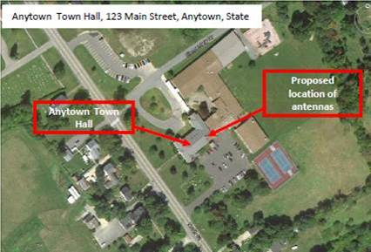
Aerial Photographs. The example in Figure 1 provides the name of the site, physical address and proposed location for installing new equipment. This example of a labeled aerial photograph provides good context of the surrounding area.

Figure 1. Example of labeled, color aerial photograph.

Ground-level photographs. The ground-level photograph in Figure 2 supplements the aerial photograph in Figure 1, above. Combined, they provide a clear understanding of the scope of the project. This photograph has the name and address of the project site, and uses graphics to illustrate where equipment will be installed.

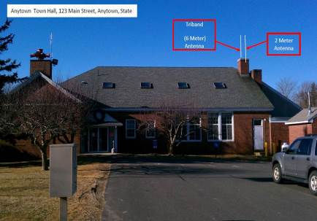

Figure 2. Example of ground-level photograph showing proposed attachment of new equipment

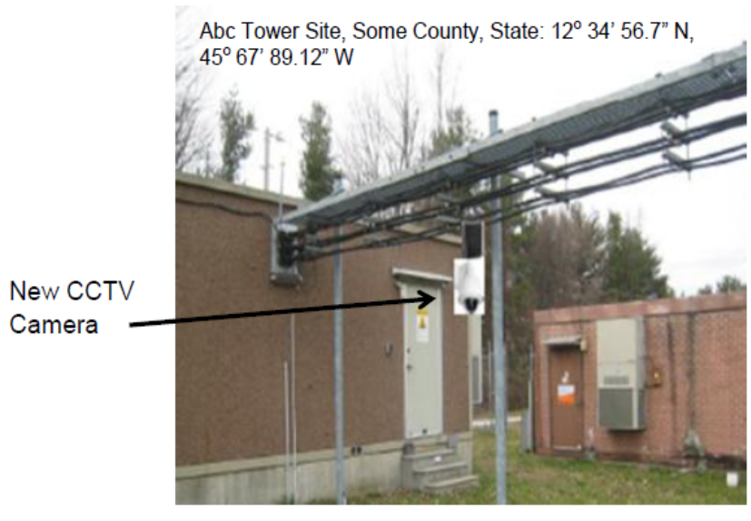
Ground-level photograph with equipment close-up. Figure 3 includes a pasted image of a CCTV camera that would be placed at the project site. Using desktop computer software, such as PowerPoint,¹ this can be accomplished by inserting a graphic symbol (square, triangle, circle, star, etc.) where the equipment would be installed. This example includes the name and location of the site. The site coordinates are in the degree-minute-second format.

Figure 3. Ground-level photograph with graphic showing proposed equipment installation.

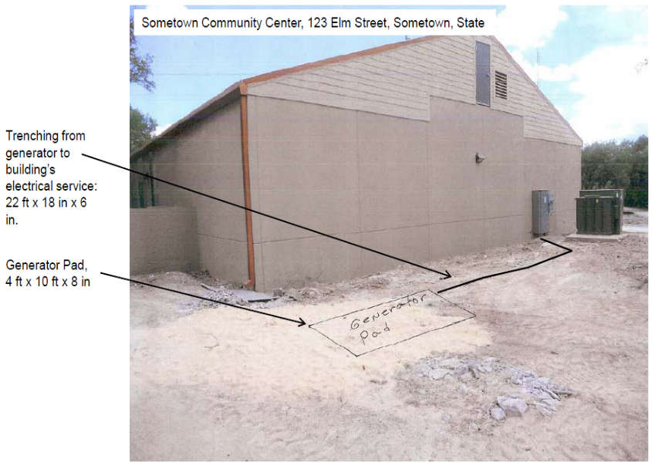
Ground-level photograph with excavation area close-up. The example in Figure 4 shows the proposed location for the concrete pad for a generator and the ground disturbance to connect the generator to the building’s electrical service. This information can be illustrated with either an aerial or ground-level photograph, or both. This example has the name and physical address of the project site.

Figure 4. Ground-level photograph showing proposed ground disturbance area.

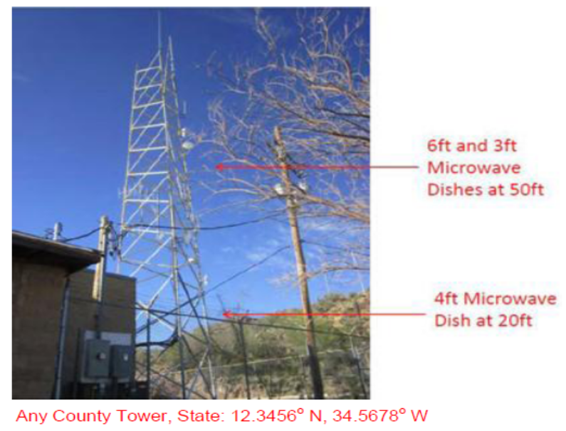
Communications equipment photographs. The example in Figure 5 supports a project involving installation of equipment on a tower. Key elements are identifying where equipment would be installed on the tower, name of the site and its location. This example provides site coordinates in decimal format.

Figure 5. Ground-level photograph showing proposed locations of new communications equipment on an existing tower.

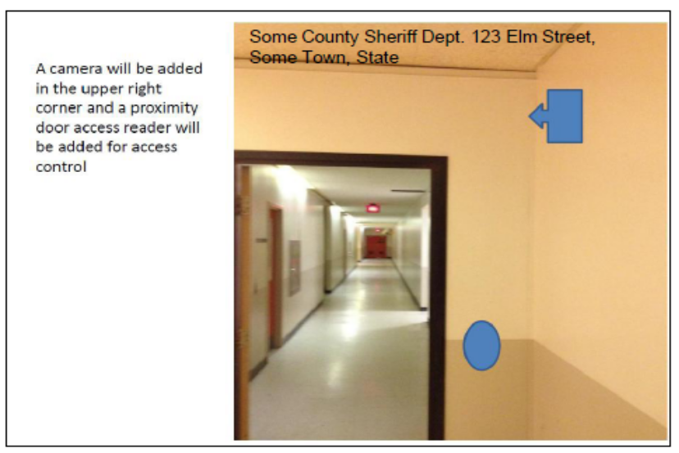
Interior equipment photographs. The example in Figure 6 shows the use of graphic symbols to represent security features planned for a building. The same symbols are used in the other pictures where the same equipment would be installed at other locations in/on the building. This example includes the name of the facility and its physical address.

Figure 6. Interior photograph showing proposed location of new equipment.

Ground-level photographs of nearby historic structures and buildings. Consultation with the State Historic Preservation Office (SHPO) may be required for projects involving structures that are more than 50 years old, or are on the National Register of Historic Places. In that event, it will be necessary to provide a color, ground-level photograph of each side of the building/structure.

Use of brand name does not constitute product endorsement, but is intended only to provide an example of the type of product capable of providing an element of the EHP documentation.

